# Plugins

## Nivo light box

## Owl.carusel.min

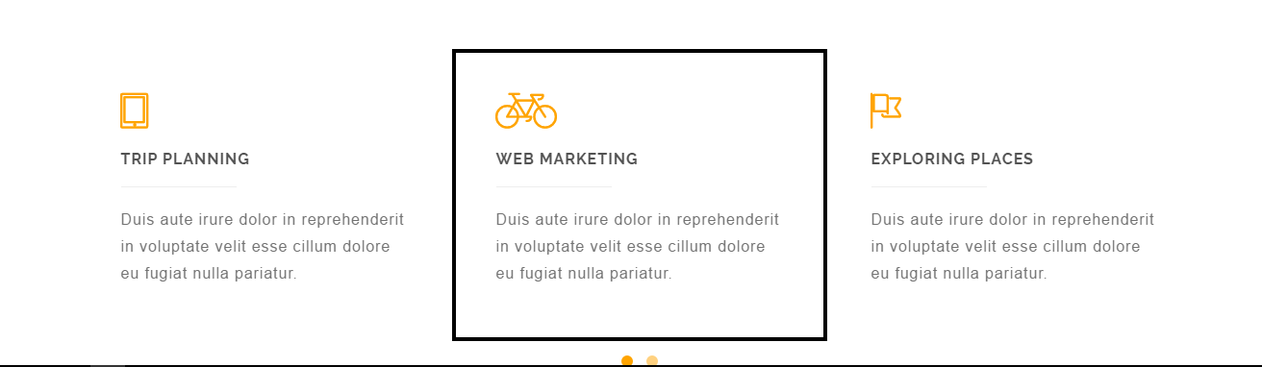

## Plugins .js



## Custom.js

Connect all together

## BootStrap

Controll our resizing settings



## Smothscroll.js

Those buttons scrolling smooth

